**Building Water Management**

**Ministry Category:** Government of Maharashtra

#### Problem Statement: Power or Water consumption in the offices, schools, hostels and facilities.

**Team Leader Name:**

**IDEA:**

The objective of the idea is to eliminate water overflow and monitor water level in big buildings and mega structures where relatively huge quantity of water is being used. The same concept can be scaled to small buildings at a relatively low cost.

**Proposed Solution** not only reduces the overflow of overhead tanks but also creates a transparent system to track water consumption in each block in real time thereby reducing water wastage and also generates usage pattern for the building to predict future demand.

**PROCESS and TECHNOLOGY STACK:**

Building water management and its associated strategies are always overlooked during construction of a building. While most of us undervalue the significance of water, there has been a change in the thought process of technologists towards the way water is being consumed in buildings. This change is mainly driven by droughts during summer and people growing consciously looking at the way they are charged per gallon of water consumed. This in-turn led to a program called Green Buildings and the problems associated came into the limelight.

In this project overall water consumption of a building is evaluated using Key Fixtures Approach. Water consumption at various outlets is measured using sensors right from pump to all along pipe diversions, tanks and fixtures. Water to overhead tank is controlled using float sensor and solenoid valves. The sensor data is fed to a control algorithm which monitors & controls solenoid valves, measure water consumed at different location of the building detect leaks and broadcast the entire data to cloud in real-time. A mobile app is developed to read data from the cloud and generate metrics, plots and insights. The control algorithm also sends alerts to mobile app on pipe leaks, operation & maintenance requirements and provision to log corrective actions taken.

The data aggregator (cloud) provides further insights when applied analytics on the data collected. Insights can be gallons of water consumed per person per day/month/year, predicting the water consumption in the near future, warrant maintenance and repair (predictive maintenance) etc… In most cases a turnkey solution is most viable as building configuration, the way water is supplied to the whole building, number of pumps and water sources are different.

An effective strategy for water management in buildings depends on our ability to measure, monitor and report water consumption; this is accomplished using the proposed approach.

**Technologies used:** MATLAB/Simulink, ThingSpeak Cloud

**Hardware used:** Raspberry Pi/NodeMCU, Float Sensors, Level Sensors, Solenoid Valves, Relay Modules, DC Adapter

**USE CASE:**

We often face water overflow/leakage in overhead tanks at house/office etc… This problem can be resolved by placing a simple controller to turnoff motor when the tank is full. This technique doesn’t provide the user of any water leaks, usage etc… which helps the user to conserve water. The proposed solution provides insights on these areas and helps users to conserve water and save money on electricity bills.

When the overhead tank is full the relay trips the motor supply avoiding overflow of tank. The overhead tank is fitted with a float sensor (normally open) which closes the trip circuit when water level reaches the sensor position. Another level sensor is provided in the tank to broadcast the water level in the tank in real time. This is accomplished using Raspberry Pi board provided with an Ethernet cable to send data to the cloud (in this case ThingSpeak platform is used).

An alternative to Raspberry Pi is low cost Wi-Fi module NodeMCU. The setup with NodeMCU is simple and cheap compared to Raspberry Pi setup but demands good strength of Wi-Fi connectivity. Since it is very sensitive to the Wi-Fi connectivity provided, Raspberry Pi with Ethernet is relatively more reliable.

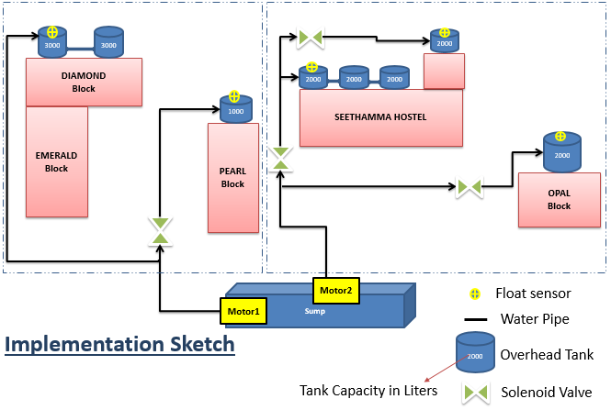

**BOM:**

Only Auto Trip: SMPS (230/12V/5A), Solid State Relay (according to motor ratings), MCBs, DOL starter, Float Sensor, Level Sensor.

Auto Trip & IoT Enabled: Ultrasonic sensor/Level Sensor, ESP8266/Raspberry pi 2 Model B, Ethernet Cable (RJ45 jack) and material included above.

**Cost Analysis:**

|  |  |  |
| --- | --- | --- |
| Distance\Feature | Only Auto Trip | Auto Trip IoT Enabled |
| Distance between motor and Tank is around 300m | Rs. 2930 | Rs. 7515 |
| Distance between motor and Tank is less than 200m | Rs. 2230 | Rs. 6815 |

**DEPENDENCIES:**

* Internet connectivity at installed location.
* Update existing plumbing system to accommodate solenoid valves.
* Need continuous power supply to monitor water level.

**TEAM LEADER:** S Shravani **E-mail ID:** [15WH1A0255@bvrithyderabad.edu.in](mailto:15WH1A0255@bvrithyderabad.edu.in)

**Team Member1:** G Sai Deepika **E-mail ID:** [15WH1A0254@bvrithyderabad.edu.in](mailto:15WH1A0254@bvrithyderabad.edu.in)

**Team Member2:** K Pranathi **E-mail ID:** [15WH1A0237@bvrithyderabad.edu.in](mailto:15WH1A0237@bvrithyderabad.edu.in)

**Team Member3:** S Sruthi Meghana **E-mail ID:** [16WH1A0247@bvrithyderabad.edu.in](mailto:16WH1A0247@bvrithyderabad.edu.in)

**Team Member4:** K Pranathi **E-mail ID:** [15WH1A0237@bvrithyderabad.edu.in](mailto:15WH1A0237@bvrithyderabad.edu.in)

**Team Member5:** S Sruthi Meghana **E-mail ID:** [16WH1A0247@bvrithyderabad.edu.in](mailto:16WH1A0247@bvrithyderabad.edu.in)